Stress Testing

Extreme situations that can affect the application may cause the performance of the software to suffer as a result. In terms of the Apollo application, the situation under which the application can come under stress is when it is subjected to a heavy load in terms of the network in question. As a result, the stress test for the Apollo application would require checking the network capacity and the number of connections it can handle without affecting its performance. Additionally, the times under which the Apollo application may come under high stress can also be anticipated, as it will be expected that more users will attempt to simultaneously connect to the application during times of the year when it is time to schedule for courses for the following semesters.

The Apollo application is currently hosted on GoDaddy. With over 61 million domains under its management, it is the world’s largest ICANN-accredited registrar. With its capability to handle a very large volume of users and connections, having the application hosted on GoDaddy has ensured that the application can handle a high volume of simultaneous connections without affecting the performance of the software, as well as an even greater volume of viewers as GoDaddy only considers a user to be connected while they are actively downloading content from the application [1].

Since the application is hosted on GoDaddy, the information regarding how many connections the application can maintain is available on the GoDaddy account. It revealed that the application can handle 100 concurrent connections without affecting its performance. After testing an API call to the server, the average connection duration was approximately 1000 milliseconds. This means that the Apollo applications can serve approximately 100 people per second, and 6000 people per minute.

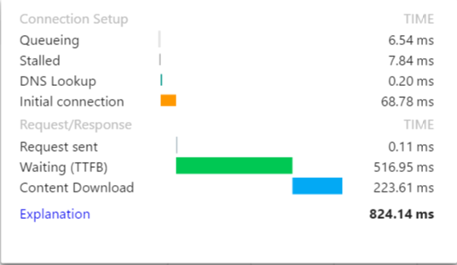

[1] GoDaddy, “How many viewers can view my site at once?” 2016. [Online]. Available:

<https://ca.godaddy.com/help/how-many-visitors-can-view-my-site-at-once-3206#cpanel>